

JSPM's Rajarshi Shahu College of Engineering
An Empowered Autonomous Institute Affiliated to Savitribai Phule Pune University ,Approved by AICTE,
Accredited by NBA(UGPrograms), Accredited by NAAC With "A" Grade MHRD-NIRF Rank:151-200

AcademicYear2024-25

MINIPROJECT REPORT- PYTHON
“MOVIE BOOKING SYSTEM”

UnderTheGuidanceOf:- Prof.S.R.Paralkar

GROUP MEMBERS:-

NAME | ROLLNO. | RBT NO.
GEET AROTE | CS2124 | RBT23CS024
SAINATH BAGADE | CS2126 | RBT23CS026
PRANAV CHOUDHARY | CS2129 | RBT23CS029
ROHIT GIRAM | CS2136 | RBT23CS036

1.Abstract:

The cinema booking system is designed to simplify the process of booking movie tickets online. The system allows users to browse available movies, view schedules, book tickets, and manage reservations in an intuitive interface. It ensures ease of use for customers and efficient management for cinema owners.

2.Introduction Of your project :

This project aims to develop a Python-based cinema booking system, utilizing file handling. The system will manage movie listings, ticket availability, and bookings while ensuring a seamless user experience.

a.Software model used :

The Waterfall Model is chosen for this project due to its structured and sequential approach, which aligns well with the clear and predictable requirements of the cinema booking system. Each phase of the model (Requirement Analysis, Design, Coding, Testing, and Implementation) is completed fully before moving on to the next, reducing the chances of confusion and ensuring well-documented progress.

3.Requirement Analysis:

In this phase, we identify the key functional and non-functional requirements of the cinema booking system. The system should allow users to view movie schedules, select seats, and process bookings, while ensuring scalability and security. These requirements form the foundation for the design and implementation of the system.

4.Design:

The design phase focuses on creating the architecture of the system, including the data flow and database structure. The system will have distinct modules for user authentication, movie management, and ticket booking. Additionally, class diagrams and flowcharts are created to represent the overall structure of the software.

5.Coding:

This phase involves writing the code for the cinema booking system based on the design specifications. The system is developed using Python and involves the implementation of various classes such as Movie, Screen, Booking, and User. Each module is implemented individually and then integrated into the system.

6.Testing

Testing ensures that the cinema booking system operates as expected and meets the specified requirements. Various types of testing were performed:

Unit Testing: Each module (e.g., user authentication, seat selection) was tested individually.

Integration Testing: Modules were integrated, and interactions between them were tested.

System Testing: The entire system was tested to validate its overall functionality.

Acceptance Testing: The system was tested by users to ensure it meets their requirements.

Importance of the Testing Phase
- Ensures quality and stability of the product.
- Helps prevent costly fixes by identifying bugs early.
- Increases customer satisfaction by delivering reliable software.
- Reduces risk by verifying all critical functionalities are working.

7.Implementation:

The implementation of the cinema booking system included deploying the system on a local server for testing. Users could successfully browse movie listings, book tickets, and view their booking history. Screenshots of the system in action are provided below:

8.Conclusion:

The cinema booking system developed using Python provides a user-friendly interface for booking movie tickets. By following the Waterfall Model, we ensured that each phase was completed fully before moving to the next, leading to a stable and functional system. The system is easy to use and can be extended to include additional features like online payment integration and promotional offers.

9.Future Scope:

Future improvements to the cinema booking system may include the following:

Integration with payment gateways for online transactions.

Development of a mobile application to extend accessibility.

Dynamic pricing algorithms for peak and off-peak times.

Integration with third-party services for promotions and advertisements.

DATA FLOW DIAGRAM

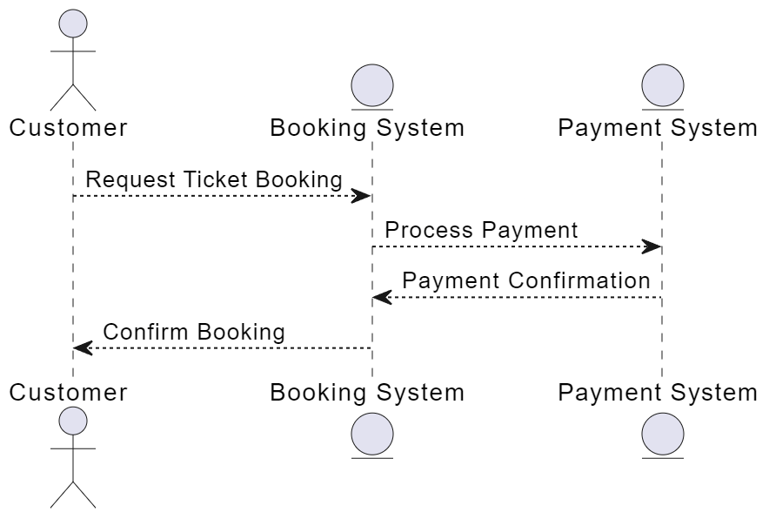

CODE:

import tkinter as tk

from tkinter import messagebox

import csv

import random

import hashlib

from tkinter import ttk

# File to store movie and booking data

MOVIES_FILE = "movies_data.csv"

BOOKINGS_FILE = "bookings_data.csv"

# Admin credentials storage

stored_username = None

stored_password = None

unique_key = None

# Encryption functions

def encrypt_data(data, key):

return ''.join(chr(ord(char) + key) for char in data)

def decrypt_data(data, key):

return ''.join(chr(ord(char) - key) for char in data)

# File to store admin credentials

ADMIN_FILE = "cinema_admin_credentials.txt"

# Function to write to CSV files

def write_movie_data(movie_data):

with open(MOVIES_FILE, mode='a', newline='', encoding='utf-8') as file:

writer = csv.writer(file)

writer.writerow(movie_data)

def write_booking_data(booking_data):

with open(BOOKINGS_FILE, mode='a', newline='', encoding='utf-8') as file:

writer = csv.writer(file)

writer.writerow(booking_data)

# Generate unique key during sign-up

def generate_unique_key():

return random.randint(1000, 9999)

# Admin sign-up

def admin_signup():

def submit_signup():

global stored_username, stored_password, unique_key

admin_username = username_entry.get()

admin_password = password_entry.get()

confirm_password = confirm_password_entry.get()

favorite_movie = favorite_movie_entry.get()

if len(admin_password) < 8 or not any(char.isdigit() for char in admin_password):

messagebox.showerror("Error", "Password must be at least 8 characters long and contain letters and numbers.")

return

if admin_password != confirm_password:

messagebox.showerror("Error", "Passwords do not match!")

return

unique_key = generate_unique_key()

stored_username = admin_username

stored_password = hashlib.sha256(admin_password.encode()).hexdigest()

with open(ADMIN_FILE, "w") as file:

file.write(stored_username + "\n")

file.write(stored_password + "\n")

file.write(favorite_movie + "\n")

file.write(str(unique_key) + "\n")

messagebox.showinfo("Success", f"Admin signed up successfully! Your unique key is {unique_key}.")

signup_window.destroy()

signup_window = tk.Toplevel(root)

signup_window.title("Admin Sign-Up")

tk.Label(signup_window, text="Username").pack(pady=10)

username_entry = tk.Entry(signup_window)

username_entry.pack()

tk.Label(signup_window, text="Create Password").pack(pady=10)

password_entry = tk.Entry(signup_window, show="*")

password_entry.pack()

tk.Label(signup_window, text="Confirm Password").pack(pady=10)

confirm_password_entry = tk.Entry(signup_window, show="*")

confirm_password_entry.pack()

tk.Label(signup_window, text="Favorite Movie (for password recovery)").pack(pady=10)

favorite_movie_entry = tk.Entry(signup_window)

favorite_movie_entry.pack()

tk.Button(signup_window, text="Submit", command=submit_signup).pack(pady=10)

# Admin login

def admin_login():

def submit_login():

global stored_username, stored_password, unique_key

admin_username = username_entry.get()

admin_password = password_entry.get()

if not stored_password or not stored_username:

try:

with open(ADMIN_FILE, "r") as file:

stored_username = file.readline().strip()

stored_password = file.readline().strip()

unique_key = int(file.readlines()[-1].strip())

except FileNotFoundError:

messagebox.showerror("Error", "No admin registered.")

login_window.destroy()

return

hashed_password = hashlib.sha256(admin_password.encode()).hexdigest()

if admin_username == stored_username and hashed_password == stored_password:

messagebox.showinfo("Success", "Login successful!")

login_window.destroy()

admin_panel()

else:

messagebox.showerror("Error", "Incorrect username or password!")

login_window = tk.Toplevel(root)

login_window.title("Admin Login")

tk.Label(login_window, text="Enter Admin Username").pack(pady=10)

username_entry = tk.Entry(login_window)

username_entry.pack()

tk.Label(login_window, text="Enter Admin Password").pack(pady=10)

password_entry = tk.Entry(login_window, show="*")

password_entry.pack()

tk.Button(login_window, text="Login", command=submit_login).pack(pady=10)

# Admin panel with view movie catalog and bookings

def admin_panel():

admin_panel_window = tk.Toplevel(root)

admin_panel_window.title("Admin Panel")

def view_catalog():

catalog_window = tk.Toplevel(admin_panel_window)

catalog_window.title("Movies Catalog")

movies = []

with open(MOVIES_FILE, mode='r', encoding='utf-8') as file:

reader = csv.reader(file)

for row in reader:

movies.append(row)

tree = ttk.Treeview(catalog_window, columns=('Movie', 'Time', 'Seats Available'), show='headings')

tree.heading('Movie', text='Movie')

tree.heading('Time', text='Time')

tree.heading('Seats Available', text='Seats Available')

for row in movies:

tree.insert('', 'end', values=row)

tree.pack(fill=tk.BOTH, expand=True)

def view_bookings():

bookings_window = tk.Toplevel(admin_panel_window)

bookings_window.title("Bookings List")

bookings = []

with open(BOOKINGS_FILE, mode='r', encoding='utf-8') as file:

reader = csv.reader(file)

for row in reader:

bookings.append(row)

tree = ttk.Treeview(bookings_window, columns=('User', 'Movie', 'Seats Booked'), show='headings')

tree.heading('User', text='User')

tree.heading('Movie', text='Movie')

tree.heading('Seats Booked', text='Seats Booked')

for row in bookings:

tree.insert('', 'end', values=row)

tree.pack(fill=tk.BOTH, expand=True)

tk.Button(admin_panel_window, text="View Movie Catalog", command=view_catalog).pack(pady=10)

tk.Button(admin_panel_window, text="View Bookings", command=view_bookings).pack(pady=10)

tk.Button(admin_panel_window, text="Logout", command=admin_panel_window.destroy).pack(pady=10)

# Add Movie from Root Page (admin functionality)

def add_movie():

def submit_movie():

movie_name = movie_name_entry.get()

movie_time = movie_time_entry.get()

seats_available = seats_available_entry.get()

write_movie_data([movie_name, movie_time, seats_available])

messagebox.showinfo("Success", "Movie added successfully!")

add_window.destroy()

add_window = tk.Toplevel(root)

add_window.title("Add Movie")

tk.Label(add_window, text="Movie Name").pack(pady=5)

movie_name_entry = tk.Entry(add_window)

movie_name_entry.pack(pady=5)

tk.Label(add_window, text="Movie Time").pack(pady=5)

movie_time_entry = tk.Entry(add_window)

movie_time_entry.pack(pady=5)

tk.Label(add_window, text="Seats Available").pack(pady=5)

seats_available_entry = tk.Entry(add_window)

seats_available_entry.pack(pady=5)

tk.Button(add_window, text="Submit", command=submit_movie).pack(pady=10)

# User login and book seats

def user_booking():

def submit_booking():

user_name = user_name_entry.get()

selected_movie = movie_listbox.get(tk.ACTIVE)

seats_to_book = seats_entry.get()

# Fetch movie data and update seat availability

movies = []

with open(MOVIES_FILE, mode='r', encoding='utf-8') as file:

reader = csv.reader(file)

for row in reader:

if row[0] == selected_movie:

available_seats = int(row[2])

if int(seats_to_book) <= available_seats:

row[2] = str(available_seats - int(seats_to_book))

write_booking_data([user_name, selected_movie, seats_to_book])

messagebox.showinfo("Success", f"Booked {seats_to_book} seats for {selected_movie}!")

else:

messagebox.showerror("Error", "Not enough seats available!")

return

movies.append(row)

# Update the CSV file

with open(MOVIES_FILE, mode='w', newline='', encoding='utf-8') as file:

writer = csv.writer(file)

writer.writerows(movies)

booking_window.destroy()

booking_window = tk.Toplevel(root)

booking_window.title("Book Movie Tickets")

tk.Label(booking_window, text="Your Name").pack(pady=5)

user_name_entry = tk.Entry(booking_window)

user_name_entry.pack(pady=5)

tk.Label(booking_window, text="Select Movie").pack(pady=5)

# Display movies in a listbox

movie_listbox = tk.Listbox(booking_window)

with open(MOVIES_FILE, mode='r', encoding='utf-8') as file:

reader = csv.reader(file)

for row in reader:

movie_listbox.insert(tk.END, row[0])

movie_listbox.pack(pady=5)

tk.Label(booking_window, text="Number of Seats").pack(pady=5)

seats_entry = tk.Entry(booking_window)

seats_entry.pack(pady=5)

tk.Button(booking_window, text="Book", command=submit_booking).pack(pady=10)

# Main application window

root = tk.Tk()

root.title("Cinema Booking System")

welcome_label = tk.Label(root, text="Welcome to Cinema Booking System", font=("Arial", 16, "bold"))

welcome_label.pack(pady=20)

admin_signup_button = tk.Button(root, text="Admin Sign Up", bg="#FF5722", fg="white", font=("Arial", 14, "bold"), command=admin_signup)

admin_signup_button.pack(pady=10)

admin_login_button = tk.Button(root, text="Admin Login", bg="#FF9800", fg="white", font=("Arial", 14, "bold"), command=admin_login)

admin_login_button.pack(pady=10)

add_movie_button = tk.Button(root, text="Add Movie", bg="#2196F3", fg="white", font=("Arial", 14, "bold"), command=add_movie)

add_movie_button.pack(pady=10)

user_booking_button = tk.Button(root, text="Book Movie Tickets", bg="#4CAF50", fg="white", font=("Arial", 14, "bold"), command=user_booking)

user_booking_button.pack(pady=10)

# Run the application

root.mainloop()

IMPLEMENTATION:

